I put three starters in, and my car still cranks slow. Does my car have VD (voltage drop)? By Bruce Amacker

It’s too often that you will change a starter that cranks slow before testing things to make sure the problem is the starter. There’s an easy test for available electricity to a component and it’s called a Voltage Drop Test. You may know how to test the battery voltage and many have the ability to properly load test the battery, but some fail to understand a simple test to verify that sufficient power is getting to the starter. Battery cables are the obvious weak link and that pesky ground strap that is usually under the transmission on VW’s.

The voltage drop test is quite simple- verifying that there is sufficient power getting to the starter under load. Under load is the key phrase here- we can all check for voltage at the starter, but making sure it doesn’t drop off under load is where many tests fall short. This test takes only seconds using the simplest of voltmeters. Set your digital volt meter on DC volts. Hook the red lead of your meter to the battery positive post and the black lead of your meter to the starter stud, not the cable end. Having long alligator clip leads on your meter will come in handy here. Disable your ignition by disconnecting the coil lead to prevent the engine from starting during the test. Have your assistant crank the engine 5-7 seconds while you watch the meter, it should not read higher than .5VDC, and most should read .2VDC or less. If it does exceed .5V it indicates high resistance in the circuit, like a bad or corroded battery cable. I’ve seen cables that looked perfect visually and would not pass enough amperage to light a headlight! Repeat the test on the ground side of the system by connecting to the ground post of the battery and the case of the starter, once again it should read well below .5VDC while cranking. On the ground side your problem could be not only the battery ground strap, but also the ground strap under the transmission. I’ve even seen corroded starter mounting flanges be the problem, where the starter is bolted tight to the transmission case, but not grounded!

This test is important not only to diagnose the slow cranking problem, but also to prove to the parts store counterman that you really do understand electricity and all three of those starters he sold you really were defective. Sidebar: If the nose bushing on the regular SR15X starter is worn, it can cause excessive amp draw because the starter shaft will bind. Be sure to inspect or replace the bushing whenever the starter or engine is out. If you are using the “autostick” style starter, this does not apply.

This test can be applied to virtually every electrical component or circuit on any car- starter, alternator, generator, wiper motor, headlights, taillights, radio, etc. in the same manner- one DVOM lead on the power source and one lead on the power terminal into the component. Do you have one dim headlight bulb? Instead of disassembling everything in the system, diagnose the circuit by doing a VD test on the power side of the headlight, and then the ground side of the headlight. Common problems in this circuit may be a loose or corroded fuse, or a corroded ground wire. Many times these components will look fine visually, which is why it’s important to test them electrically.

Have fun, good luck, and keep driving those classic VW’s!

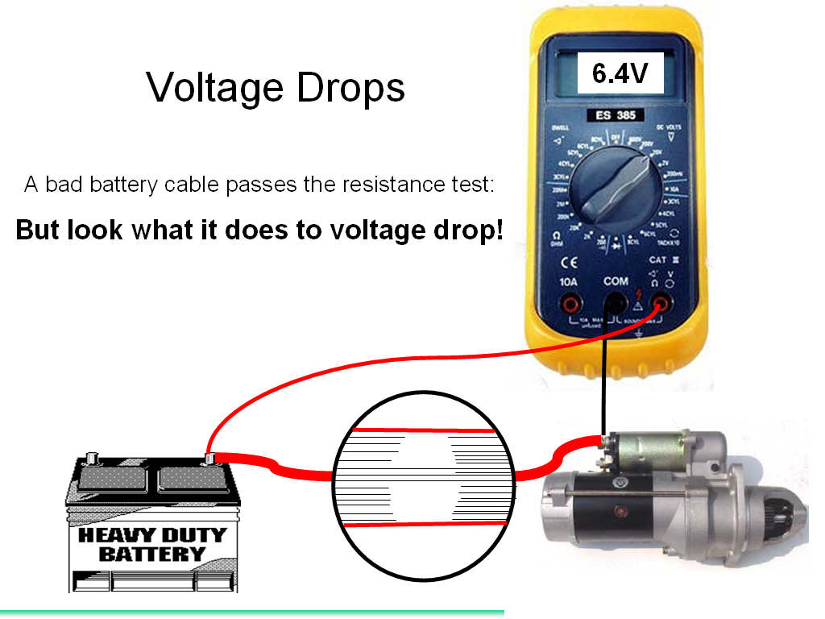

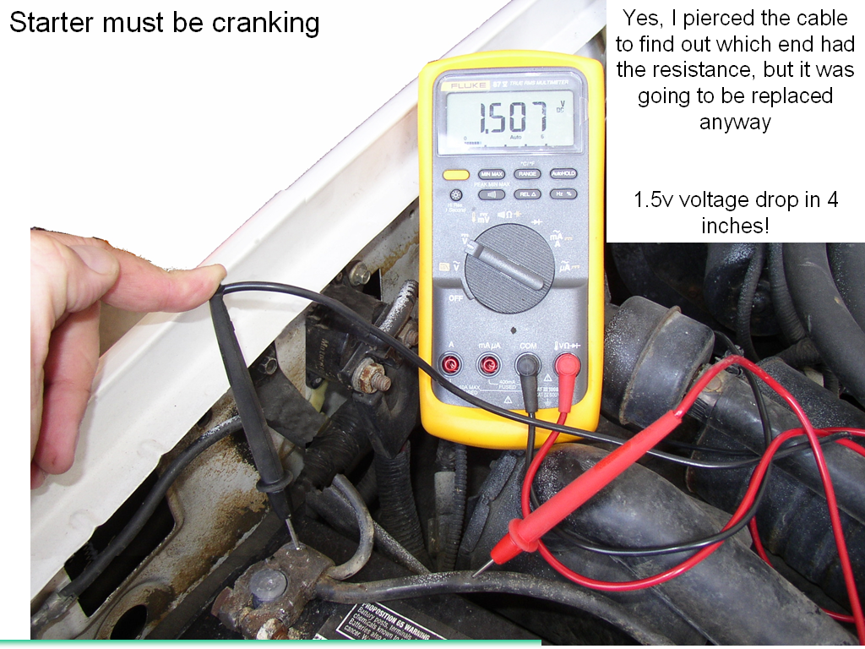
V

